Order to Cash (O2C) Return Flow Architecture

Understanding Return Authorization, Credit Memo, Customer Refunds, Inventory Reversal & Financial Impact
Weekly Learning Series – Week 15
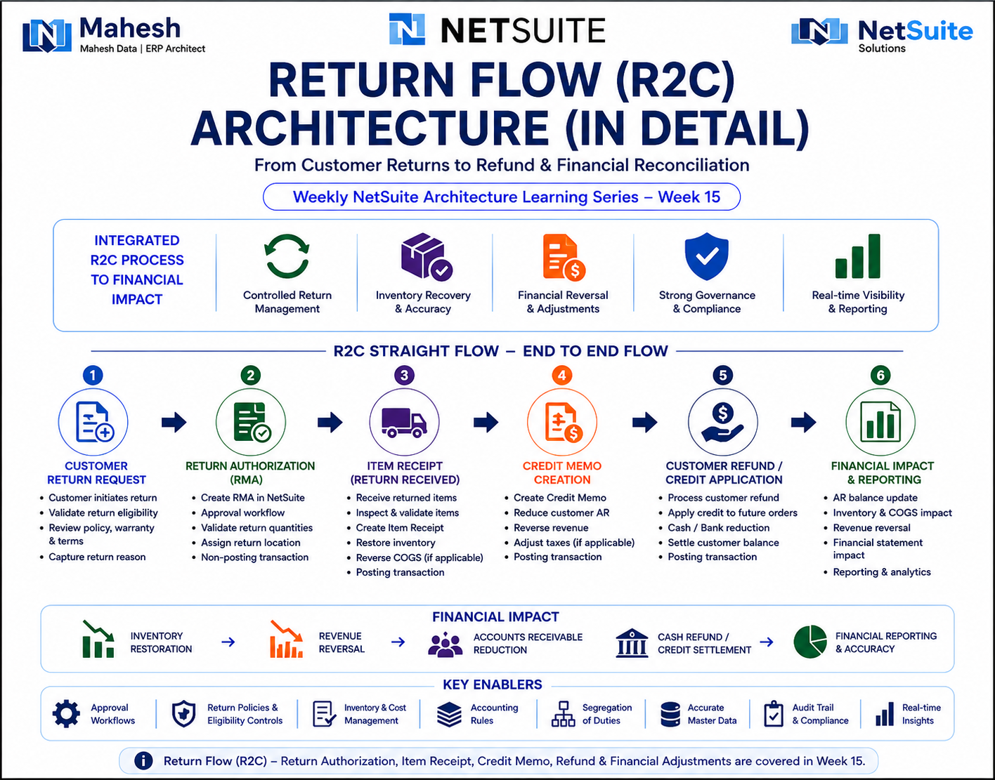

1. Introduction
- The Order to Cash0 (O2C) Return Flow process in NetSuite governs how organizations manage customer product returns, financial reversals, refunds, and inventory corrections after the original Order-to-Cash lifecycle is completed.
- While the O2C lifecycle focuses on revenue realization, the return flow manages operational reversals, customer compensation, inventory recovery, and financial correction mechanisms.
- The return architecture becomes critically important for:
  - product-based businesses,
  - e-commerce operations,
  - warranty processing,
  - damaged goods management,
  - customer dissatisfaction handling,
  - and compliance-driven financial adjustments.
- A standard Return Flow generally includes:
  - Customer Return Request
  - Return Authorization (RMA)
  - Item Receipt
  - Credit Memo Generation
  - Refund or Credit Application
  - Financial Reconciliation
- ERP systems do not experience emotional exhaustion when customers return products they ordered impulsively at 2 AM during “limited-time sales.” Humans in finance and warehouse teams unfortunately do.

2. Return Flow Architecture
- The Return Flow represents the operational and financial reversal lifecycle within NetSuite.
- The architecture ensures:
  - inventory correction,
  - controlled financial reversal,
  - customer refund tracking,
  - audit traceability,
  - and accurate GL reporting.
- The complete return lifecycle generally includes:
  - Customer Return Request
  - Return Authorization Approval
  - Item Receipt Processing
  - Inventory Inspection
  - Credit Memo Creation
  - Refund or Credit Settlement
  - Financial Reconciliation
- Core NetSuite modules involved:
  - Order Management
  - Inventory Management
  - Accounts Receivable
  - Financial Management
  - Customer Service
  - Reporting & Analytics

2.1 Transaction Relationship Chain
- NetSuite maintains return transaction relationships using native “Created From” transaction linkage.
- Return transactions preserve traceability between:
  - original sales transactions,
  - return authorizations,
  - inventory receipts,
  - credit memos,
  - and customer refunds.

Architectural Importance
- Maintains audit-ready transaction history
- Supports customer dispute tracking
- Enables financial reversal traceability
- Simplifies inventory reconciliation
- Supports operational visibility

Example Return Chain
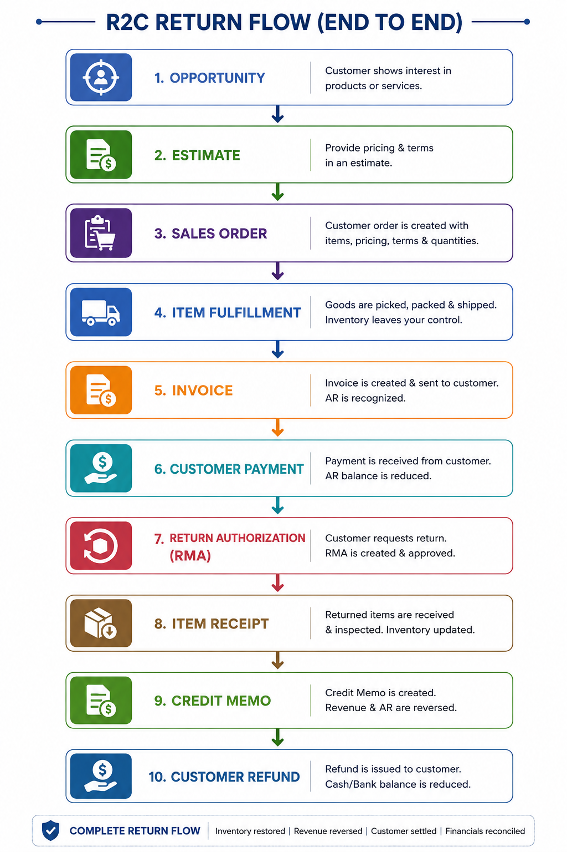
- One Invoice may generate:
  - multiple RMAs,
  - multiple Credit Memos,
  - and multiple Refund transactions.
- This becomes especially important in partial return scenarios.

3. Alternative Return Processing Models
NetSuite supports multiple return processing approaches depending on business operations.

3.1 Standard Inventory Return Flow

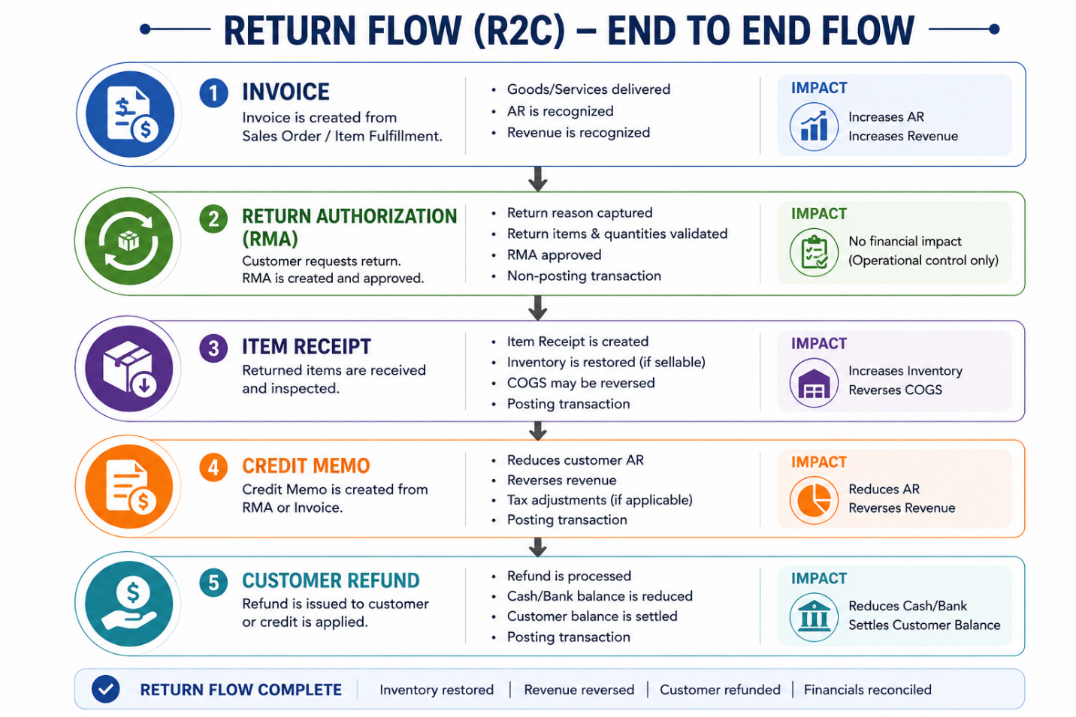

Common Use Cases
- Physical inventory returns
- Damaged product returns
- Warranty returns
- E-commerce returns
- Distribution operations

3.1.1 Warranty Replacement Flow

Some return scenarios require replacement fulfillment instead of direct customer refund processing.

Typical replacement flow:
Return Authorization
↓
Item Receipt
↓
Replacement Sales Order
↓
Item Fulfillment

This model is commonly used in:
- warranty operations,
- manufacturing industries,
- electronics support models,
- and service replacement programs.

Architectural Importance

Replacement architectures impact:
- inventory allocation,
- fulfillment planning,
- warranty expense tracking,
- customer service operations,
- and financial reconciliation.

3.2 Financial-Only Credit Adjustment
In some scenarios:
- inventory is not physically returned,
- but financial compensation is still required.

Typical Flow
Invoice
↓
Credit Memo

Common Use Cases
- pricing disputes,
- service failures,
- customer goodwill adjustments,
- shipping charge reversals,
- tax corrections.

Architectural Importance
Different return models impact:
- inventory valuation,
- revenue reversal timing,
- customer liabilities,
- and refund processing.
Because humans occasionally demand refunds for products they fully used and somehow still consider “unsatisfactory.” Civilization remains a fragile experiment.

3.3 Feature Dependency Architecture
Multiple NetSuite platform features influence return transaction behavior and operational sequencing.
Advanced Shipping
- Separates fulfillment processing from invoice generation.
- Impacts downstream return eligibility and fulfillment traceability.
Advanced Receiving
- Separates inventory receiving from billing adjustments.
- Enables more controlled warehouse inspection and staged return processing.
Advanced Billing
- Supports partial billing and staged customer invoicing.
- Impacts partial return and partial credit scenarios.
Advanced Revenue Management (ARM)
- Controls revenue reversal timing and compliance behavior.
- Return transactions may impact deferred revenue schedules and performance obligations.
Multi-Location Inventory
- Supports distributed return locations and warehouse-based return routing.

Architectural Importance
Transaction sequencing and financial impact behavior may vary depending on enabled NetSuite features and organizational accounting configuration.

4. End-to-End Return Lifecycle

Stage 1 — Customer Initiates Return
- Customer requests return or refund
- Customer service validates eligibility
- Original transaction reviewed
- Return reason captured
- Warranty or policy validation performed

Stage 2 — Return Authorization (RMA)
- Return Authorization created in NetSuite
- Approval workflow may trigger
- Return quantities validated
- Return location assigned
- RMA itself is generally non-posting

Stage 3 — Item Receipt
- Returned items physically received
- Warehouse inspection performed
- Item Receipt transaction created
- Inventory may be restored depending on item condition
- Inventory Asset is typically increased when returned inventory is accepted back into stock.
- COGS reversal may occur depending on accounting configuration

Inventory Disposition Handling

Returned inventory is not always automatically restored into sellable stock.
Organizations may classify returned inventory into multiple disposition categories:
- Restockable Inventory
- Damaged Inventory
- Scrap Inventory
- Warranty Replacement Inventory
- Vendor Return Inventory

Depending on inventory condition and organizational policy:
- inventory may be returned to active stock,
- transferred to quarantine locations,
- written off,
- returned to vendors,
- or excluded from resale availability.

Architectural Importance

Inventory disposition management directly impacts:
- inventory valuation,
- warehouse operations,
- inventory availability,
- financial write-offs,
- and audit traceability.

Stage 4 — Credit Memo Generation
- Credit Memo created from RMA or Invoice
- Customer AR balance reduced
- Revenue reduction or reversal may occur depending on accounting configuration and revenue recognition rules.
- Tax adjustments may occur
- Financial correction recorded

Stage 5 — Customer Refund or Credit Application
- Refund processed to customer
- Open credit may be applied to future invoices
- Cash or bank account reduced during refund
- Customer balance settled

Stage 6 — Financial Reconciliation
- Refund reconciliation
- Revenue adjustment validation
- Inventory reconciliation
- Audit validation
- Financial close verification

5. Return Authorization (RMA) Architecture
- Return Authorization is the foundational transaction for the return lifecycle.

Behavior | Description
Posting Behavior | Non-posting
Purpose | Controls return approval
Inventory Impact | No direct impact
GL Impact | No direct posting
Approval Support | Yes
Customer Linkage | Connected to Customer Master

- RMAs may originate from:
  - Customer complaints
  - Warranty requests
  - Damaged shipments
  - Incorrect deliveries
  - E-commerce return portals
  - Customer service cases

5.1 Return Authorization Status Lifecycle
Status | Description
Pending Approval | Awaiting approval workflow
Pending Receipt | Approved and awaiting physical return
Partially Received | Some items returned
Pending Refund | Financial settlement pending
Refunded | Refund completed
Closed | Return lifecycle completed

Architectural Importance
Return statuses drive:
- warehouse processing,
- refund eligibility,
- customer communication,
- financial adjustments,
- reporting visibility,
- and operational controls.
Incorrect status handling may create:
- duplicate refunds,
- inventory mismatch,
- financial overstatement,
- customer balance issues,
- and audit failures.

6. GL Impact Across Return Lifecycle
- Financial reversal occurs when inventory is received or financial correction transactions are generated.
Transaction | Posting Type | Financial Impact
Return Authorization | Non-posting | No GL impact
Item Receipt | Posting | Inventory & COGS reversal
Credit Memo | Posting | Revenue & AR reduction
Customer Refund | Posting | Cash reduction

6.1 Item Receipt GL Impact

Typical Accounting Behavior
- Dr Inventory Asset
- Cr Cost of Goods Sold (COGS)
- This reflects inventory restoration after returned goods are received.

6.2 Credit Memo GL Impact

Typical Accounting Behavior
- Dr Revenue / Sales Returns
- Cr Accounts Receivable
- This reverses customer liability and adjusts revenue recognition.

6.3 Customer Refund GL Impact

Typical Accounting Behavior
- Dr Accounts Receivable / Customer Credit
- Cr Cash / Bank
- This reflects customer repayment and cash outflow.

6.4 Refund Processing Variations
NetSuite supports multiple refund settlement approaches depending on the original transaction type and customer settlement model.

Customer Refund
- Commonly used when customer overpayments, open credits, or credit memos exist within Accounts Receivable.
- Refund is processed against the customer balance.
Cash Refund
- Commonly used in immediate payment or Cash Sale scenarios.
- Typically bypasses traditional Accounts Receivable settlement behavior.

Credit Application
- Open customer credits may be applied against future invoices instead of issuing immediate cash refunds.

Architectural Importance
Refund processing behavior may vary depending on:
- original transaction type,
- payment method,
- Accounts Receivable configuration,
- subsidiary structure,
- tax rules,
- and financial settlement policies.
Improper refund architecture may create:
- duplicate customer payouts,
- reconciliation mismatches,
- inaccurate customer balances,
- and audit compliance risks.

7. Posting vs Non-Posting Return Transactions
Transaction | Posting Type | Typical Financial Impact
Return Authorization | Non-posting | Operational approval only
Item Receipt | Posting | Inventory restoration
Credit Memo | Posting | Revenue reversal
Customer Refund | Posting | Cash settlement

Architectural Principle
Operational return transactions manage:
- approval controls,
- return validation,
- warehouse coordination,
- and customer service processing.
Posting transactions impact:
- inventory valuation,
- revenue correction,
- customer liabilities,
- cash settlement,
- and financial reporting.
This separation supports stronger internal controls and audit traceability.

8. Approval Architecture & Internal Controls
- RMA approval workflows
- Return eligibility validation
- Warranty validation
- Refund approval thresholds
- Duplicate refund prevention
- Inventory inspection controls
- Segregation of duties between warehouse, finance, and customer service teams
- Closed-period adjustment controls

- Because allowing one employee to approve returns, receive inventory, generate credits, and issue refunds is how companies accidentally donate money to chaos.

9. Real-World Failure Scenarios

Scenario 1 — Refund Without Item Receipt
- Customer refunded before inventory verification occurs.

Scenario 2 — Credit Memo Without Return Validation
- Revenue reversed incorrectly.

Scenario 3 — Duplicate Refund Processing
- Customer receives multiple refunds for the same return.

Scenario 4 — Inventory Not Restored
- Returned inventory never re-enters stock availability.

Scenario 5 — Closed Accounting Period Return
- Late return impacts prior-period reporting.

9.1 Period-End Financial Risks
Return processing across accounting periods may create significant financial and audit complexities.
Examples include:
- returns received in a later accounting period,
- delayed inventory receipt processing,
- late credit memo generation,
- deferred revenue reversal timing,
- and financial statement reconciliation differences.

Architectural Risks
Improper return timing may impact:
- revenue recognition accuracy,
- inventory valuation,
- subsidiary-level reporting,
- period-close reconciliation,
- and audit compliance.
Organizations typically implement:
- accounting period controls,
- approval restrictions,
- and financial review procedures
to minimize period-end return processing risks.

10. Advanced Architectural Considerations
- OneWorld subsidiary restrictions
- Multi-currency refund handling
- Multi-Book accounting adjustments
- Partial returns
- Serialized inventory returns
- Lot-number inventory returns
- Warranty replacement flows
- Advanced Revenue Management (ARM) reversals
- Tax engine adjustments
- Omnichannel return processing
- Warehouse Management System (WMS) integration
- Return merchandise inspection workflows
- Shopify and e-commerce platform return synchronization
- Third-Party Logistics (3PL) return coordination
- External warehouse return processing
- EDI-based return authorization flows
- Carrier tracking integration for return shipments
- Omnichannel customer return orchestration
- Customer self-service return portals
- Refund synchronization with external payment gateways

10.1 Key NetSuite Features Supporting Return Flow
Feature | Purpose
Return Authorization (RMA) | Controls customer return processing
Advanced Receiving | Separates receiving from billing adjustments
Credit Memo Processing | Supports revenue reversal
Customer Refund Processing | Supports refund settlement
Multi-Location Inventory | Supports distributed return locations
Accounting Period Management | Controls posting periods
Workflow Manager | Automates approval routing
SuiteAnalytics | Provides operational and financial visibility
WMS Integration | Supports warehouse return operations

10.2 Serialized & Lot-Controlled Return Complexity
Serialized and lot-controlled inventory returns introduce additional operational and compliance complexity.
Organizations may require:
- serial number validation,
- lot traceability,
- expiration verification,
- regulatory compliance checks,
- and inventory genealogy tracking.
This becomes critically important in:
- pharmaceutical operations,
- electronics manufacturing,
- medical devices,
- automotive industries,
- and regulated supply chain environments.

Architectural Importance
Serialized and lot-controlled returns impact:
- warehouse processing,
- inventory traceability,
- audit compliance,
- replacement workflows,
- and inventory accuracy.

11. Enterprise Return Architecture Patterns
Organizations may implement multiple return processing models depending on operational and financial requirements.
Standard Inventory Return
- Physical inventory returned and financial reversal processed.
Financial-Only Adjustment
- Revenue correction performed without physical inventory return.
Warranty Replacement Flow
- Replacement inventory shipped instead of customer refund.
Vendor Return Coordination
- Customer return may trigger downstream vendor return processing.
Omnichannel Return Architecture
- Customers may return products across stores, warehouses, and digital channels.
Drop-Ship Return Processing
- Return handling may involve external suppliers instead of organizational inventory.
Cross-Subsidiary Return Restrictions
- OneWorld environments may restrict returns across subsidiaries depending on accounting and operational structure.
Architectural Importance
Enterprise return architectures impact:
- inventory visibility,
- financial reconciliation,
- customer experience,
- tax compliance,
- operational scalability,
- and audit readiness.

12. Architect Insight
- The Return Flow lifecycle is not merely a refund process. It is a synchronized operational and financial correction architecture connecting inventory recovery, revenue reversal, customer compensation, and audit traceability.
- Strong return architecture ensures:
  - accurate inventory visibility,
  - controlled financial reversals,
  - reliable customer balance management,
  - compliant revenue reporting,
  - and audit-ready operational transparency.
- Mature ERP implementations treat returns as first-class financial events rather than “customer service side activities.” Because every returned item eventually becomes an accounting discussion whether people like it or not.

